CHEKCERS.IO

Project Plan
by

GROUP 3

Table Of Contents

Introduction ……………………………………………………………………………………………………………………….3
Project Organization..........................................………………………………………………………….…….…3
Risk Analysis.………………….………………………………………………………………………………..………………….4
Hardware/Software Requirements.…………………….………………………………….………….……………….5
Work Breakdown Schedule…..…………………………………………………………………………………….……….7
Project Schedule………………………………………………………………………………………………….….……………9
Monitoring/Reporting Mechanisms…………………………………………………………….…………..………....10
Appendices…………………………………………………………………………………………………………………..……..11

Introduction
This Project Plan provides the general framework and establishes specific strategies and milestones for execution of the Checker.io project. The Project Plan will define the project's requirements, expectations and schedule. This is a living document and will be updated as required on a regular basis until completion of the project.

Objective: Create a terminal based version of checkers using ASCII art that can be played on even the most minimalist of hardware configurations. Complete with the ability to play against either another person sharing the same machine, or against an AI opponent. Once the main loop is complete the user(s) will be able to review the game most recently played turn-by-turn.

Constraints: The system will not have a rules tutorial based on time constraints, though implementation of this could be done should work go more quickly than anticipated. It will also not be able to review games other than the one most recently played due to only using one file version being written to for recordkeeping purposes.

Project Organization (This needs filled in, with respect to group allocations. Of tasks)

Title | Name | Responsibility | Stakeholder Authorization
 | Emily Eshcoff |  | Authorized
 | Benjamin Archer |  | Authorized
 | Zachary Fike |  | Authorized
 | Jayden Brooks |  | Authorized
 | Carly Grubbs |  | Authorized
 | Fatima Jackson | Final Review and Evaluation | Authorized

Risk Analysis (This needs redone in, with respect to project specific requirements, Excel file can be found in repo. Convert to formatted table as well.)

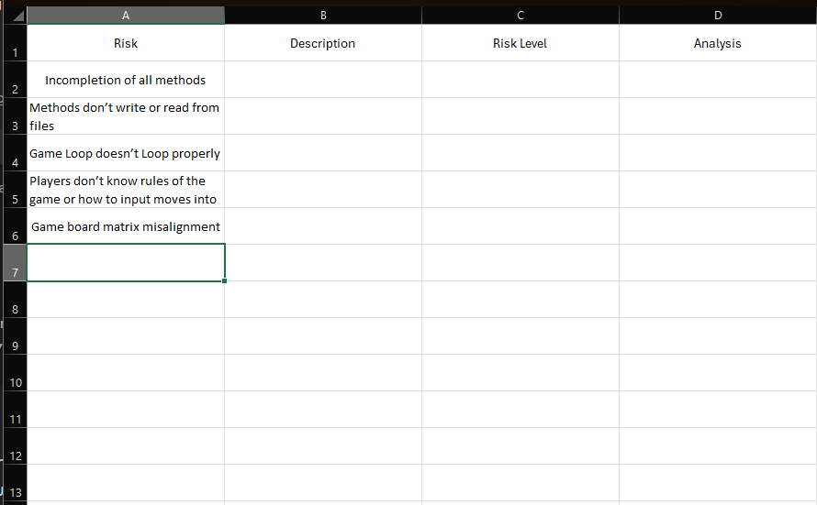

\

Leftover from example file for reference.
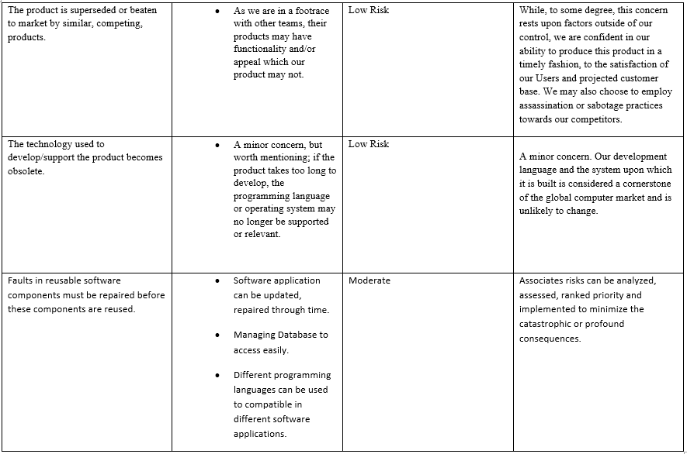

Hardware/Software Requirements (Untouched, will redo in later version. Can easily be calculated before due date. Main format can be reused. Just update 3rd column specifications.)

Specification A | Processor | - Any processor capable of running a terminal
Specification B | RAM | - 32 MB
Specification C | Storage | - 1 MB
Specification D | Network Adapter | - N/A
Specification E | Operating System | - Windows, Linux, macOS
Specification F | Programming Language | - C++
Specification G | Compiler | - MSVC, GCC, Clang
Specification H | Terminal Application | - cmd, PowerShell, bash

Work Breakdown Schedule First image is from excel, needs further details filled, Example images also left in for reference. Will use due dates on the Class Canvas or Syllabus to fill in date related details. Can also use final submissions requirements for task definitions.

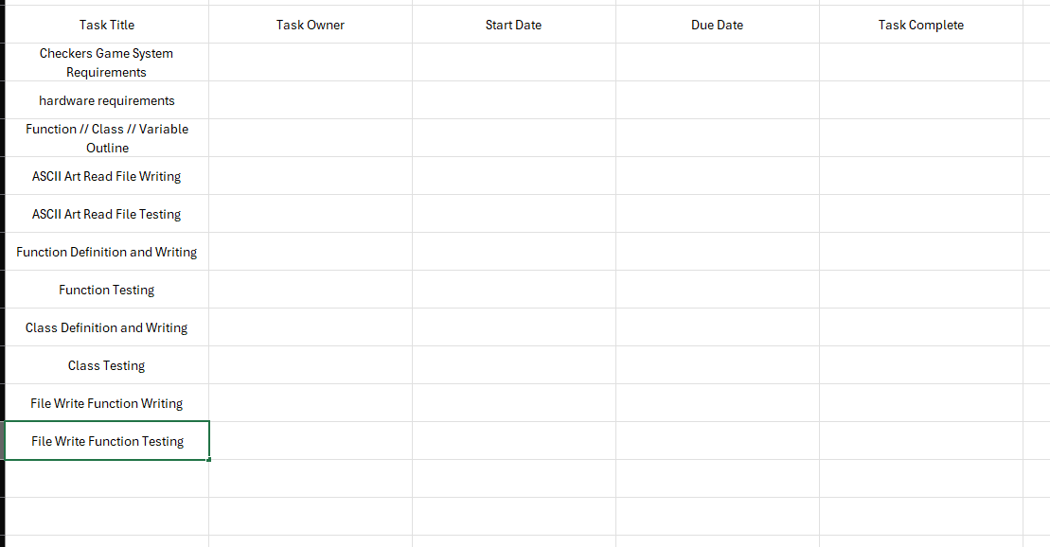

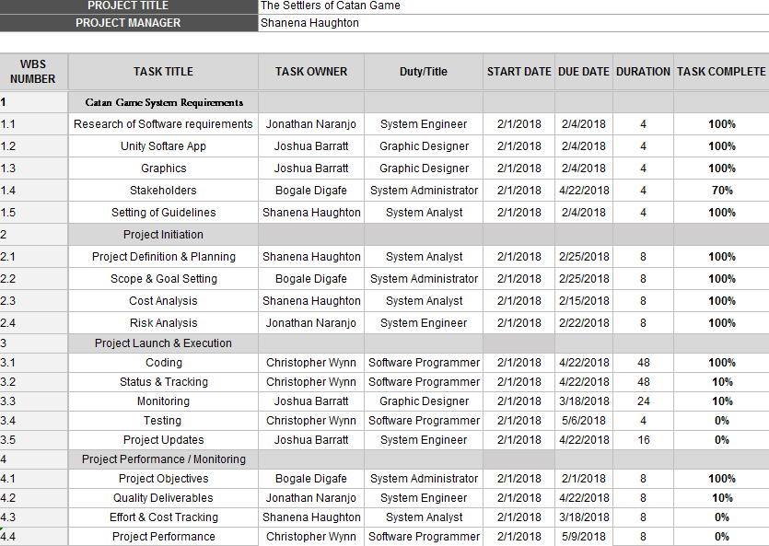

Work Breakdown Schedule (continued)
We probably don’t need this level of detail, but if anyone wants to make something like this it cant hurt. Would be nice to include past tasks already completed just for due diligence. Ie, repo creation and configuration, discord server creation and config, ect.

Project Schedule
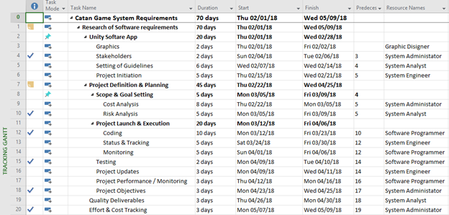
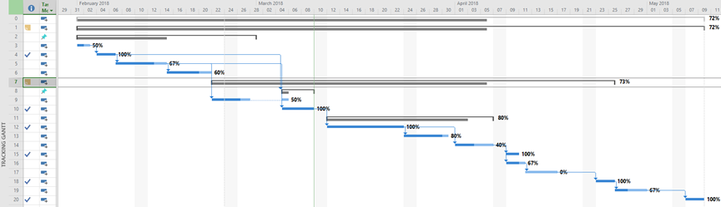

Monitoring and Reporting Mechanisms
Not sure how to change this for us. But we could figure something out.

Monitoring | Frequency
Meetings | Weekly
Deliverables | Determined by Project Schedule
Scrum | Daily via Slack

Reporting | Frequency
Activity Reports | Bi-monthly
WBS | As detailed in schedule

Appendix

We just need to replace these fields with respect to our project and this specific plan proposal.

Number of Activity | Description | Time Estimate | Dependencies
1 | Project Organization | 1 week | None
2 | Risk Analysis | 4 weeks | None
3 | Hardware/Software Requirements | 2 weeks | None
4 | Work Breakdown Schedule | 6 weeks | Project Organization; Project Scheduling
5 | Project Schedule | 15 weeks | Project Organization; Hardware/Software Requirements; Work Breakdown Schedule
5 | Monitoring/Reporting Mechanisms | 15 weeks | Project Organization; Hardware/Software Requirements; Work Breakdown Schedule; Project Schedule

